Factor Track is not a race but a game of skill.
Below is a simple training version. The idea is to go round the track in as few turns as possible, keeping to the rules.
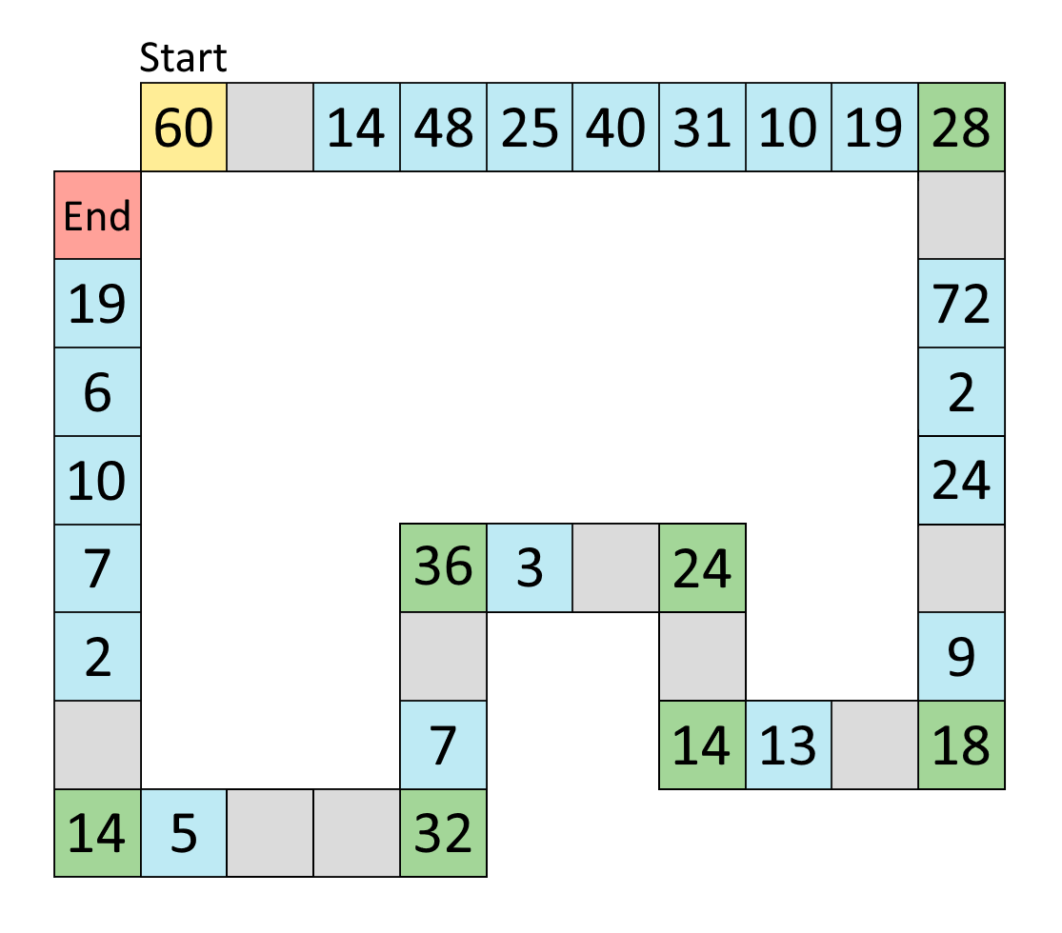
Rules:
You start on the 'Start' square and must make your way round to the 'End' square.
You can move any factor of the number you are on, except 1.
You must land exactly on each corner (green) square, so you can't go round corners in one turn.
Have a go at moving round this 'training' track following the rules.
Can you do it in fewer turns?
When you feel ready, try this more complicated track where there are possible short cuts. You will have to work out whether they are worthwhile.
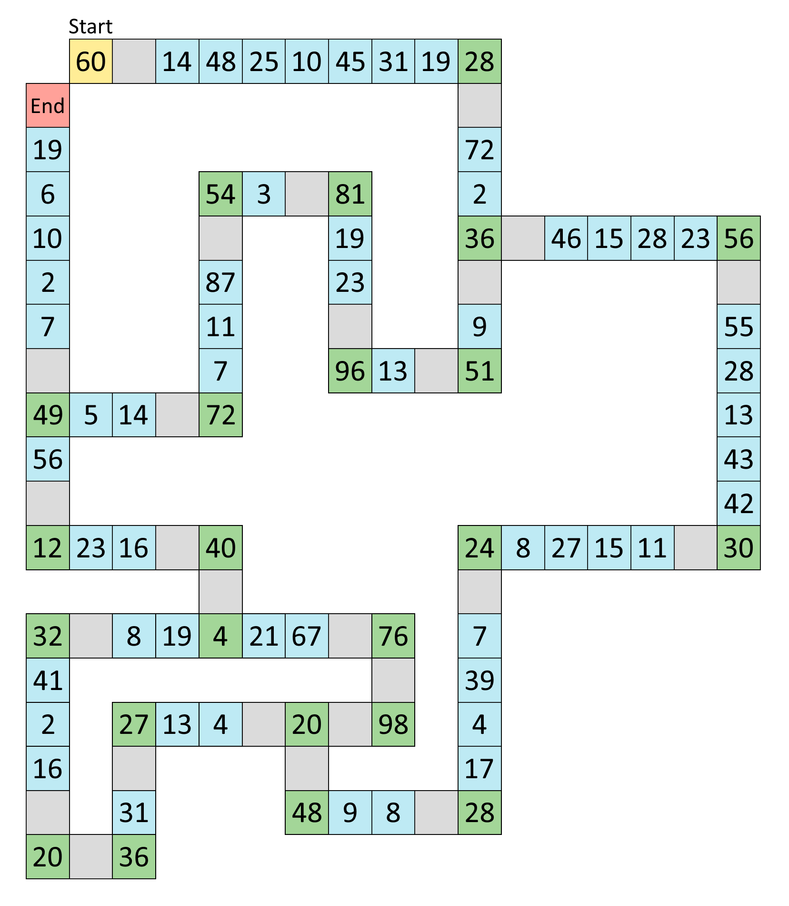
You can do this on your own or with a friend. Who can get round in the least number of turns?
What is the best route to take to do it in the least number of turns?
Which squares do you need to land on?

